Experiment 9 1. Create worksheet with following fields: Empno, Ename, Basic Pay (BP), Travelling Allowance (TA), Dearness Allowance (DA), House Rent Allowance (HRA), Income Tax (IT), Provident Fund (PF), and Net Pay (NP). Use appropriate formulas to calculate the above scenario. Analyze the data using appropriate chart and report the data

Step1: Table created

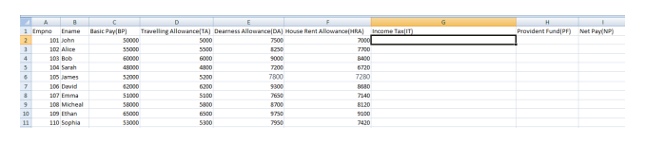

Step2: Apply formulas 1. Income Tax (IT): You can use a simple formula to calculate income tax. Assuming a tax rate of 10% ● In the cell for Income Tax of each employee, enter the formula: “=0.10\*(BP+TA+DA+HRA)”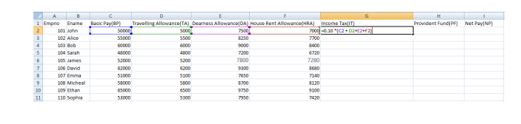

2. Provident Fund(PF): Assuming a PF rate of 8%

In the cell for Provident Fund of each employee, enter the formula: “=0.08\*(BP+TA+DA+HRA)”

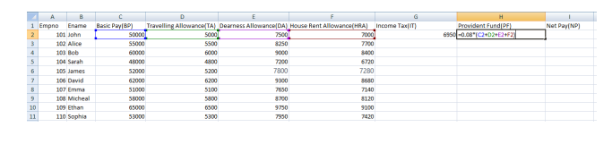

3. Net Pay (NP): Net Pay is calculated by subtracting Income Tax and Provident Fund from the total earnings. ● In the cell for Net Pay of each employee, enter the formula: “=(BP + TA + DA + HRA) - IT – PF”

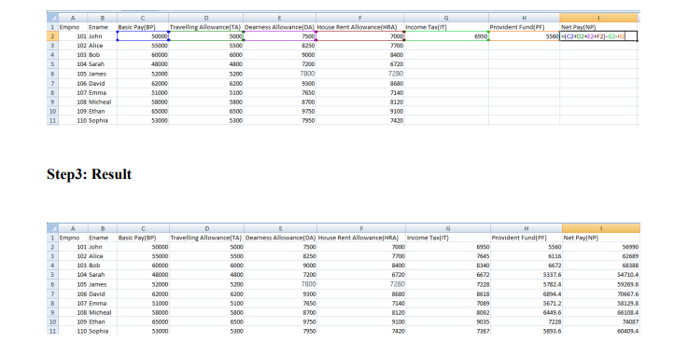

Step4: Analyze Data using chart 1. Highlight the Net Pay (NP) column for all employees. 2. Go to the "Insert" tab and select "Bar Chart" from the Charts group

3. Choose the "Clustered Bar" chart style.

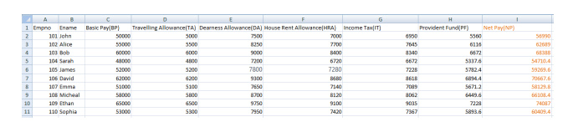

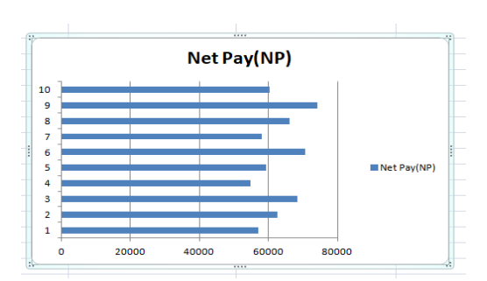

Step 5: Report the data

● Report Title: Employees Monthly Payroll Analysis

● Introduction: The purpose of this report is to analyze monthly payroll data. This analysis aims to provide insights into the financial components of employee compensation, focusing on Income Tax, Provident Fund, and Net Pay. The data includes 10 employees and their respective earnings and deductions.

● Summary of Key Metrics:

Total income tax paid: 77006

Total Provident Fund Deductions: 61604.8

Total Net Pay Distributed: 631449.2

Findings:

Employee Ethan received the highest Net Pay, while Employee Sarah had the lowest, mainly due to variations in Basic Pay and deductions.

Employee Ethan having the highest deduction and Employee Sarah the lowest.

A trend emerged, showing that higher earners often faced larger deductions, emphasizing the importance of transparent payroll policies.